Docker:
https://www.docker.com/get-started

Tomcat:
http://tomcat.apache.org/

Utorrent en Ubuntu:
el cliente es en web, y necesita un servicio http

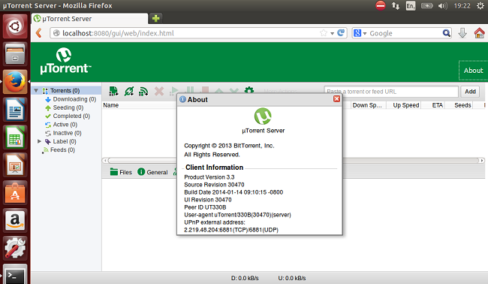

RedHat:
https://developers.redhat.com/products/

Oracle WebLogic:
https://www.oracle.com/technetwork/middleware/weblogic/downloads/index.html

Microsoft .net, con asp:
https://www.oracle.com/technetwork/middleware/weblogic/downloads/index.html

